**Organic Chemistry – Notes**

Combustion reactions:

* CO2 is always a **gas**.
* O2 is always a **gas**.
* H2O is always a **gas**.

Substitution reactions:

* H[halogen] is always a **gas**.
* [Halogen] solution is always **aqueous.**

For hydrocarbons of similar size/chain length, the melting point and boiling point depends on how close the molecules can get to each other.

* The **closer** the molecules are, the **greater the intermolecular forces** and the **greater the melting point and boiling point** because **more energy is required to overcome these forces**.
* How close the molecules can get to each other is dependent on their **stereochemistry (shape).**
* Benzenes can get closer than alkanes which can get closer than alkenes.
* Therefore, melting point and boiling point for similar size/chain length is: **alkene<alkane<benzene**.

For hydrocarbons of different size, the longer the chain (more atoms in molecule), the greater the intermolecular forces.

* This means that the **larger the molecule**, the **greater the melting point and boiling point**.
* E.g., octane has a higher melting point and boiling point than methane.

In straight-chain hydrocarbons, the carbon atoms are bonded into a **single chain of consecutive carbon atoms**. Terminal carbon atoms are bonded to 3 other hydrogen atoms and all others are bonded to 2. In a branched hydrocarbon structure, some carbon atoms **may be bonded to 3 or 4 carbon atoms**. This means there will be **side chains** to the main chain of hydrocarbons.

Alkanes are **saturated** hydrocarbons – their molecules don’t contain double bonds. Their general formula is **CnH2n+2**. Alkenes are **unsaturated** hydrocarbons – their molecules contain one double bond. Their general formula is **CnH2n**. Thus, an alkene molecule has **2 less hydrogen molecules than a corresponding alkane with the same number of carbon atoms**.

The structural formula of cyclopentane shows that each carbon atom is **bonded to 2 other carbon atoms and 2 hydrogen atoms**. This is also the case for pentane except that the **terminal carbon atoms are bonded to one other carbon atom and 3 hydrogen atoms**.

Both cyclohexane and benzene consist of a cyclic ring of 6 carbon atoms. In cyclohexane, each carbon atom is **bonded to 2 hydrogen atoms** and has a **single bond to each adjacent carbon atom**. In contrast, each carbon atom in benzene is **bonded to one hydrogen atom** and the bonds to adjacent carbon atoms are **intermediate in nature** between a single bond and a double bond.

The **octane rating is higher for molecules with branching**. Thus, for structural isomers, the octane rating is higher as the molecular formula branching increases.

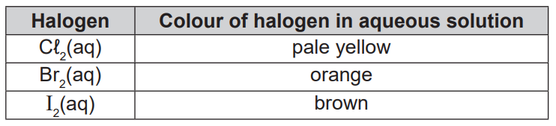

Addition reaction = **Rapid** change from [colour of halogen in aqueous solution] to colourless.

Substitution reaction = **Slow** change from [colour of halogen in aqueous solution] to colourless.